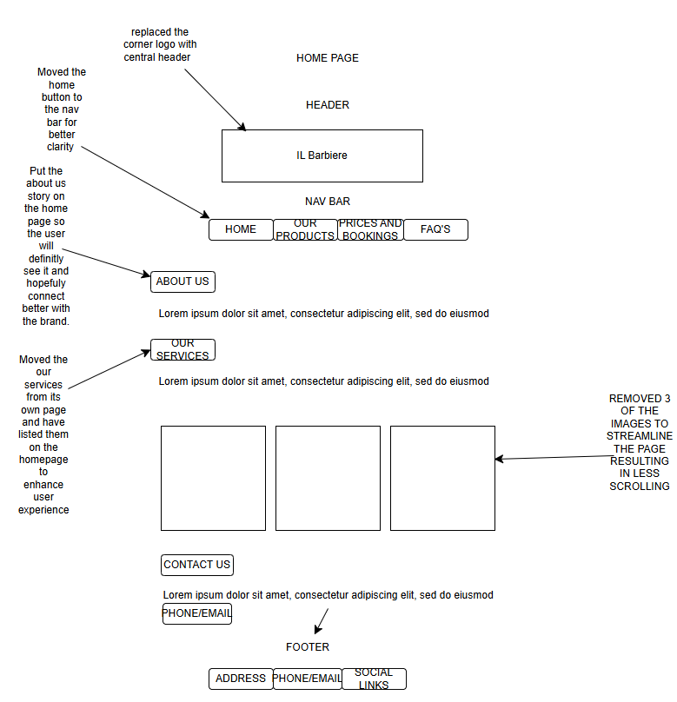
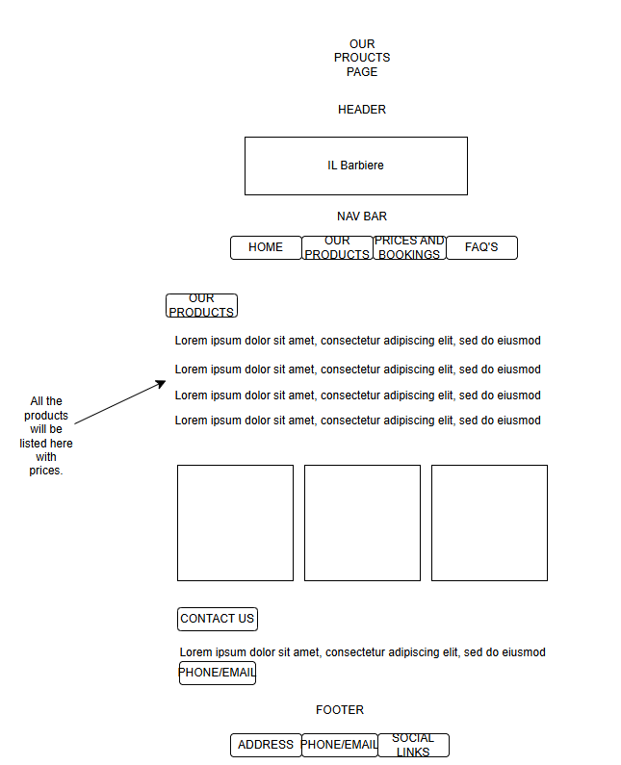
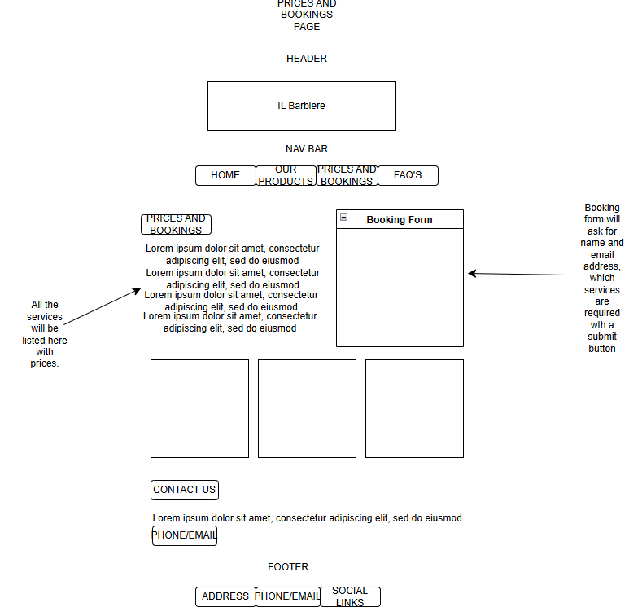
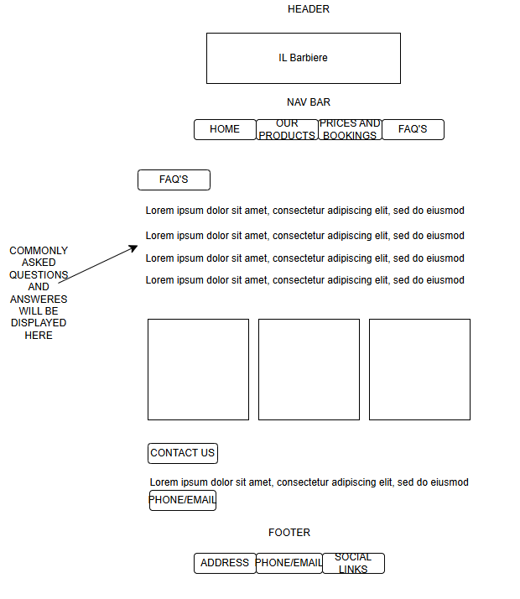There was not much feedback on the wireframes, but some changes have been made to improve the user experience. Firstly, the logo at the top left which is also a link to the home page has been removed and a clear button in the Nav bar saying home has been used instead. To not overwhelm the user with too many buttons in the nav bar, the about us has been moved to the home page directly underneath the nav bar. This provides all the important links in the nav bar for a user who is skimming the page directly for the prices and bookings or products but also putting the ”about us” section at the top so that a more casual user will automatically see it, read it and connect to the brand better.
The next improvement made is to remove the “our services” page and have the services listed on the homepage to prevent the user from becoming frustrated at having to navigate multiple pages just to get basic information. Once they have decided on the service they require, they can now go to the prices and bookings page which has all the prices and a simpler booking form.

